Risk Analysis Framework

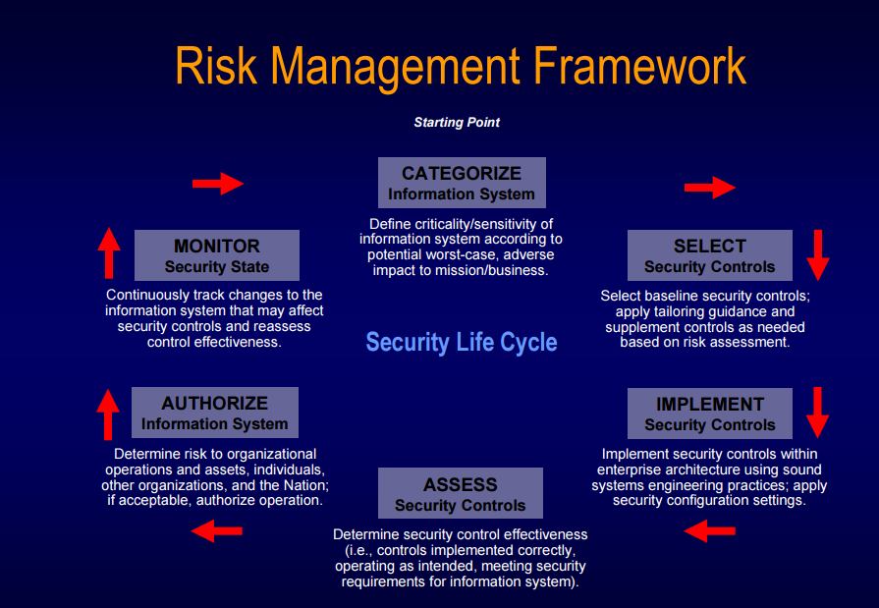

Source: <http://csrc.nist.gov/groups/SMA/fisma/documents/risk-management-framework-2009.pdf>

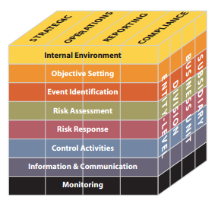

Source: <http://www.coso.org/documents/coso_erm_executivesummary.pdf>

Step 1: Laying out the Framework

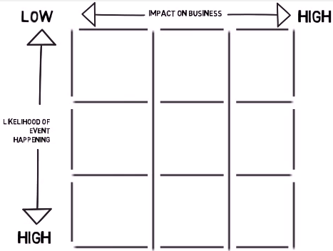

Step 2: Identify Potential Risk to the ICT system

Step 3: Classify the Risks based on the likelihood of the event happening and the impact that the event would have on the business

|  |  |  |  |
| --- | --- | --- | --- |
|  |  |  |  |
|  |  |  |  |
|  |  |  |  |
|  |  |  |  |
|  |  |  |  |

